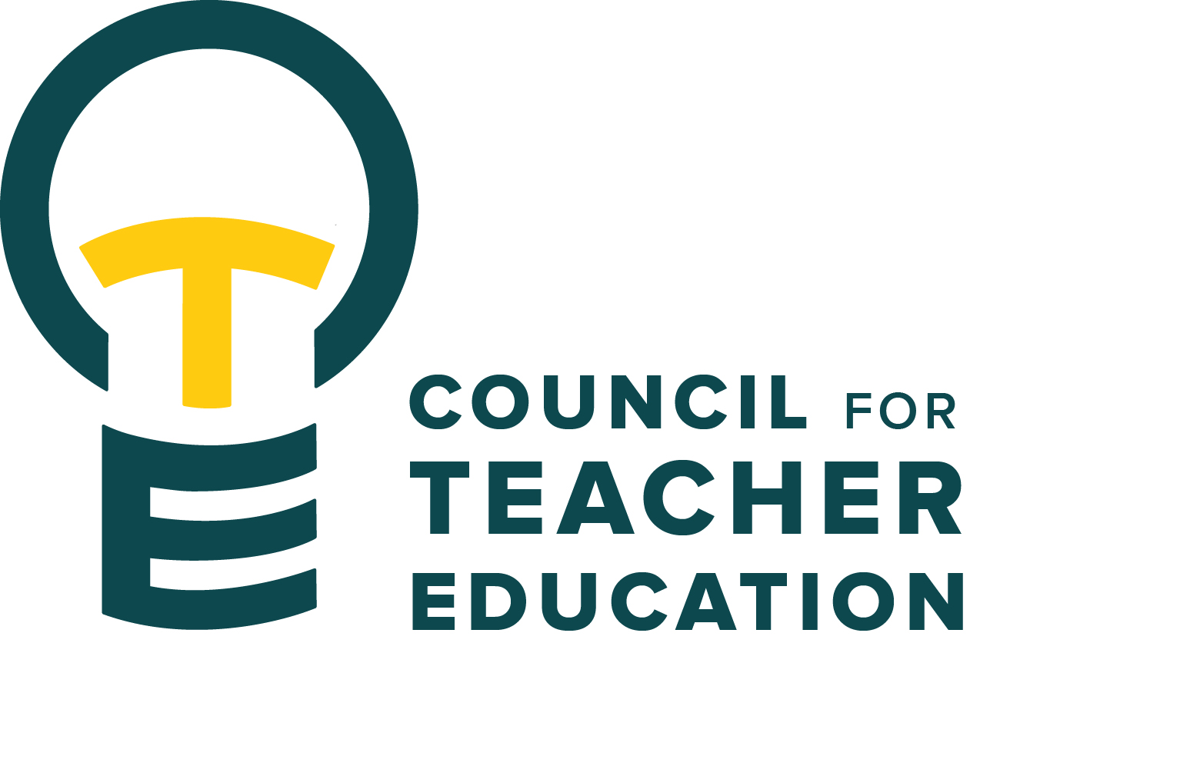

***Council for Teacher Education***

Meeting Agenda

April 18, 2023, 3:00-4:30 pm, DeGarmo 551

1. Call to order
2. Roll Call (In Attendance & Absent)
3. Approval of minutes from the April 4th meeting
4. Information Items:
5. Director, Cecilia J. Lauby Teacher Education Center, Updates
6. EDI week being recognized in COE – a full week of events and promoting awareness

V. Subcommittee Reports:

1. Curriculum (Noelle Selkow & Mary Henninger)
2. Student Interests (Jay Percell)
3. University Liaison and Faculty Interest (Yojanna Cuenca-Carlino)
4. University Teacher Education Assessment (Christy Bazan & Monica Noraian)
5. Vision (Jill Thomas)

VI. Discussion Items:

1. Committee Listening Circle Discussions about inclusive spaces
2. As a follow-up to the above discussion. Ask members to check with their programs and college colleagues what is being done to support students and what EDI work is happening in their areas. Share and record at the next CTE meeting.

VII. Action Items: 

VIII. Legislative Updates:



IX. Announcements and Last Comments:

X. Adjournment:

**Next CTE Executive Board Meeting: April 25, 2023, 2-3 pm** **Next CTE Subcommittee Meetings: April 25, 2023, 3:00-4:30 pm**

**Curriculum:** Chair -Noelle Selkow & Mary Henninger (DEG 304 3:30-4:30)

**Student Interests Committee:** Chair Jay Percell (STV 140 3:30-4:30)

**University Liaison and Faculty Interests:** Chair -Yojanna Cuenca-Carlino (DEG 504 3:00-4:30)

**University Teacher Education Assessment Committee:** Co-Chairs Bazan & Noraian (DEG 551 3:00-4:00)

**Vision:** Chair Jill Thomas (DEG 506A 3:00-4:30)

**Next CTE Meeting: May 2, 2023, 3:00-4:30 pm DeGarmo 551 2022-2023 CTE & COMMITTEE MEETING SCHEDULE**

|  |  |
| --- | --- |
| **CTE** (1st and 3rd Tuesdays) DEG 551 | **Exec & Subcommittees** (2nd and 4th Tuesdays) |
| April 18 | April 25 |
| May 2 | May 9 – use if necessary or helpful (committee report due May 15) |